**Assignment Topic**:- Mention all windows tools for debugging with Screenshots and steps to create for Microsoft Intune Portal

**E-mail ID:-** innamaf29@gmail.com

**Name**:- Batool Fatima

**User ID**:- 34723

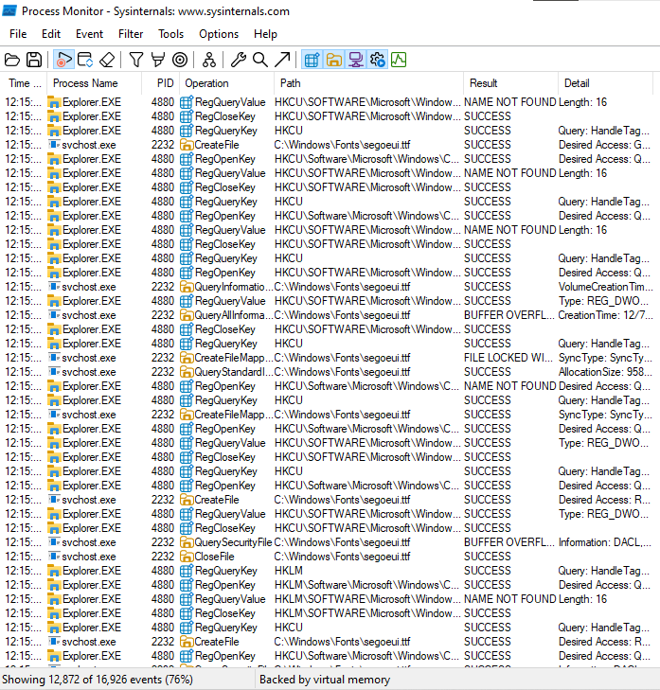

**Process Monitoring**

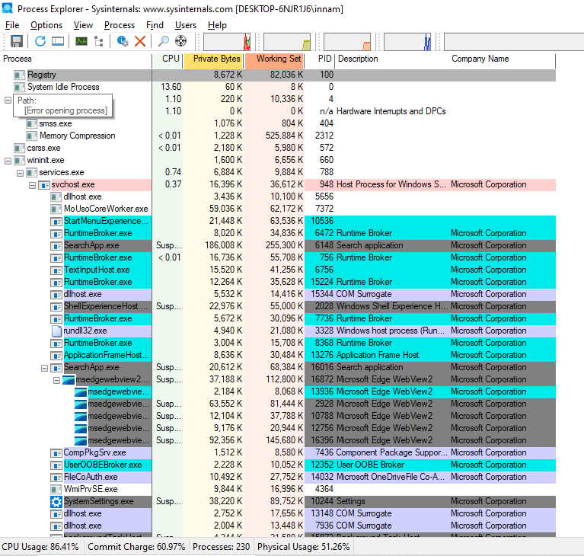

**Process Explorer**-Process Explorer is like a more advanced Task Manager. It shows which programs are running, how much memory they use, and what files they have open. It’s great for finding problems or malware.



These Sysinternals tools are helpful for fixing issues and checking security on Windows systems. **LogonSessions** helps you see which users are currently logged in to your system. **Autologon** allows a computer to log in automatically without typing a username and password every time. It's useful for systems that restart often or don't need user input. **PsExec** lets you run commands or programs on another computer remotely, as if you're sitting in front of it. It's useful for managing multiple systems. **PSTools** is a group of command-line tools (including PsExec) that help manage systems both locally and remotely. **RegMon** watches changes in the Windows Registry in real time. This helps track what programs are doing behind the scenes. **Whois** is a network tool that gives information about domain names and IP addresses, useful for checking website ownership or troubleshooting. **Sysmon** runs in the background and logs important events like process creation and network connections, helping with system security and monitoring.

**How to Set Up Microsoft Intune**

Step 1: Review the Supported Configurations. ...

Step 2: Sign Up for Intune. ...

Step 3: Configure a Domain Name for Your Intune Tenant. ...

Step 4: Add Users to Intune. ...

Step 5: Create Groups. ...

Step 6: Manage Licenses. ...

Step 7: Manage Roles and Grant Admin Permissions.

